2)Explain the purpose of comments in HTML and provide an example of how to use comments in an HTML document?

HTML <!-- --> Tag .The cooment tag is used to insert comments in the source code .In these comments tag we can explain about our code.or HTML comment tag can help when we edit our source code at a later date.But this comments are not displayedin the browser.

Exp: 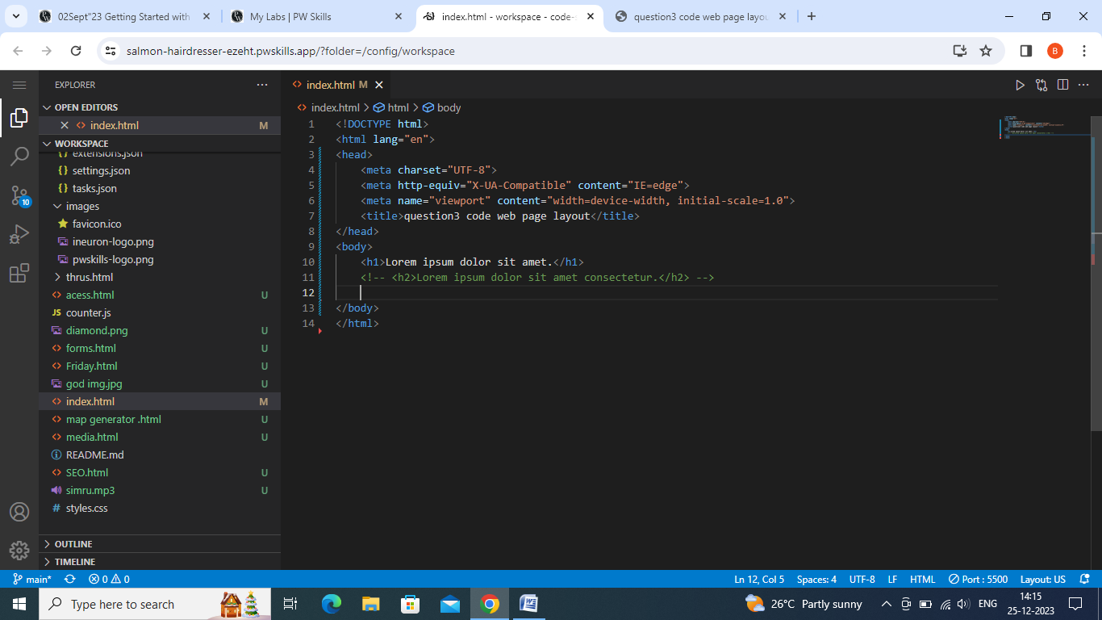 output:

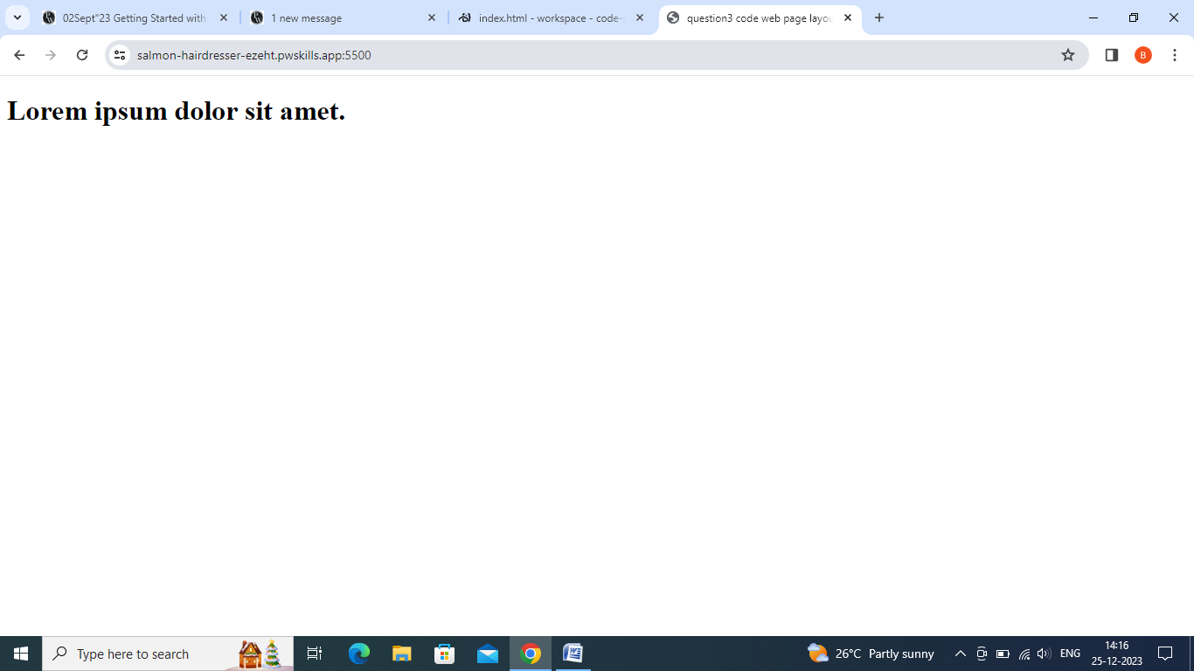

3.)write aan HTML program that includes a heading ,a paragraph of text, a horizontal line,and a line break.Arrange these elements to create a simple web pagelayout?

Code:

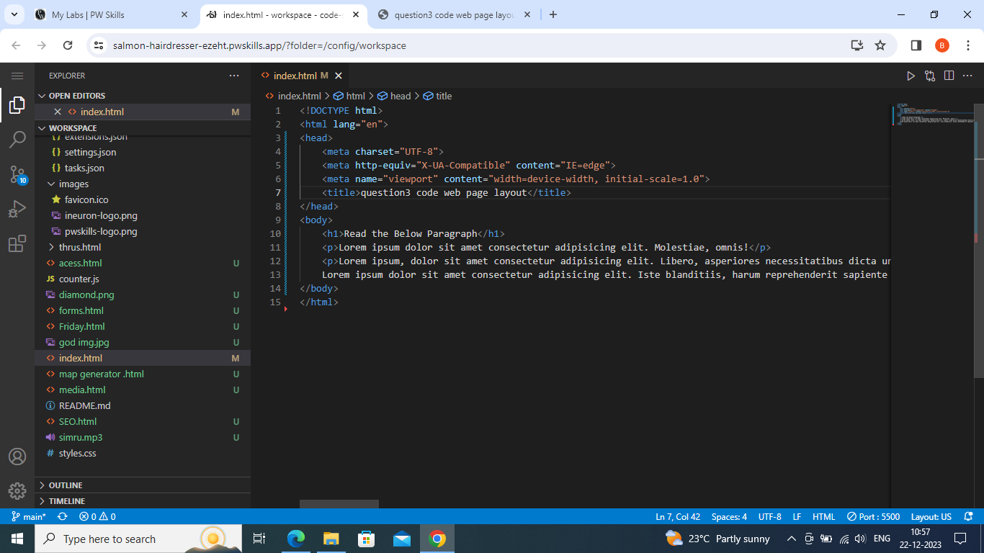 output:

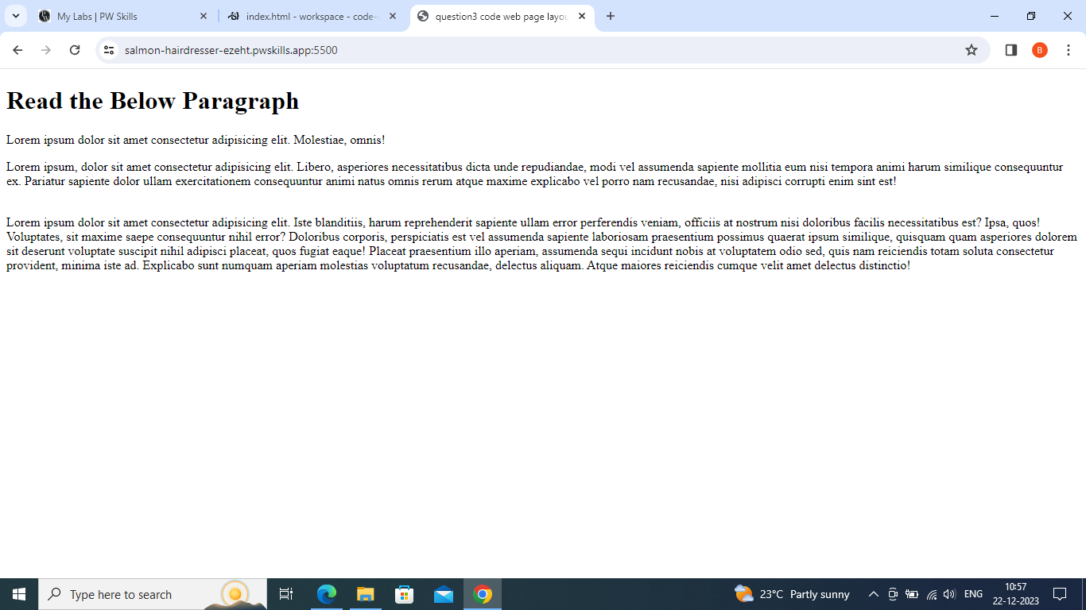

4.)Write short note on Tag and elment with an example?

Tag provide web browser with instruction about the web page ,such as where to display images ,and how the document structure .Tags are always enclose in angle brackets:< > exp:<h1>,tag usually comes in pairs .eg:<h1></h1>.

The HTML elements is everything from the start tag to the end tag.

5.)What is DOCTYPE Decleration in HTML?

It is written in first line code in HTML <!DOCTYPE html>.The Doctype decleration in HTML instruct to the web browser about what version of HTML page is written in.

1.)write a simple program in HTML that display the heading ” HTML defines the content and structure of your website “ on the web browser?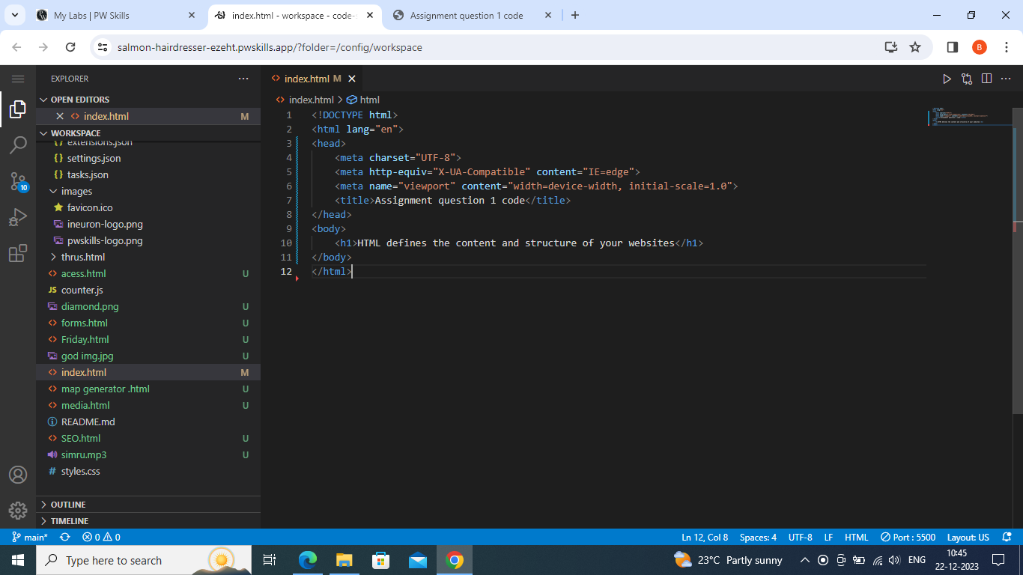output:

